Chapter 1 homework

- Run the R program HS_college_GPA.R.
- Complete exercises 1.20, 1.24, 1.28, and 1.45. Note that all data sets in KNN are on the CD accompanying the textbook. If your book did not come with it, you can download the data sets from the Chapters web page (Day #1).
- Examine the page 23-24 proofs
- Examine tests from 2012
- Reproduce all examples in the notes

Partial answers:

1.20
a) Here is my code and the corresponding output. Note that I edited this code and output after pasting it into Word to make it look nicer. Again, you are expected to do this as well.

> ############################################################################
> # NAME: Chris Bilder #
> # DATE: 7-17-06 #
> # PURPOSE: 1.20 and 1.24 in KNN #
> # #
> # NOTES: 1) #
> # #
> ############################################################################

> #Read in the data
> copier<-read.table(file = "C:\\chris\\UNL\\STAT870\\Instructor_CD\\Data
Sets\\Chapter 1 Data Sets\\CH01PR20.txt",
header = FALSE, col.names = c("minutes", "copiers"), sep = "")
> #Check first few observations
> head(copier)
minutes copiers
1 20 2
2 60 4
3 46 3
4 41 2
5 12 1
6 137 10

> #Fit the simple linear regression model and save the results in mod.fit
> mod.fit<-lm(formula = minutes ~ copiers, data = copier)
> summary(mod.fit)

Call:
lm(formula = minutes ~ copiers, data = copier)

Residuals:
Min 1Q Median 3Q Max
-22.7723 -3.7371 0.3334 6.3334 15.4039

Coefficients:
Estimate Std. Error t value Pr(>|t|)
(Intercept) -0.5802 2.8039 -0.207 0.837
copiers 15.0352 0.4831 31.123 <2e-16 ***
---
Signif. codes: 0 '***' 0.001 '**' 0.01 '*' 0.05 '.' 0.1 ' ' 1

Residual standard error: 8.914 on 43 degrees of freedom
Multiple R-Squared: 0.9575, Adjusted R-squared: 0.9565
F-statistic: 968.7 on 1 and 43 DF, p-value: < 2.2e-16

The sample simple linear regression model is 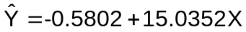 where X = number of copiers and  is the estimated number of minutes spent by the service person. One could also write the model as  in a less formal way.

b)

> #Simple scatter plot
> plot(x = copier$copiers, y = copier$minutes, xlab = "Number of copiers", ylab =
"Minutes spent by service person", main = "Minutes spent vs. Number of
copiers", col = "black", pch = 1, panel.first = grid(col = "gray", lty =
"dotted"))
> #Add sample model to plot - this is one of many ways to do it! Note that the
curve() function evaluates the "expression" listed for expr by putting in n =
101 points (default value) in for x. The "x" always has to be in expr.
> curve(expr = mod.fit$coefficients[1] + mod.fit$coefficients[2]*x, col = "red",
lty = "solid", lwd = 2, add = TRUE, from = min(copier$copiers), to =
max(copier$copiers))
> #Other ways to get the line on the plot
> #abline(a = mod.fit$coefficients[1], b = mod.fit$coefficients[2], col = "red",
lty = "solid", lwd = 2)
> #segments(x0 = min(copier$copiers), y0 = mod.fit$coefficients[1] +
mod.fit$coefficients[2]*min(copier$copiers),
x1 = max(copier$copiers), y1 = mod.fit$coefficients[1] +
mod.fit$coefficients[2]*max(copier$copiers),
lty = 1, col = "blue", lwd = 2)
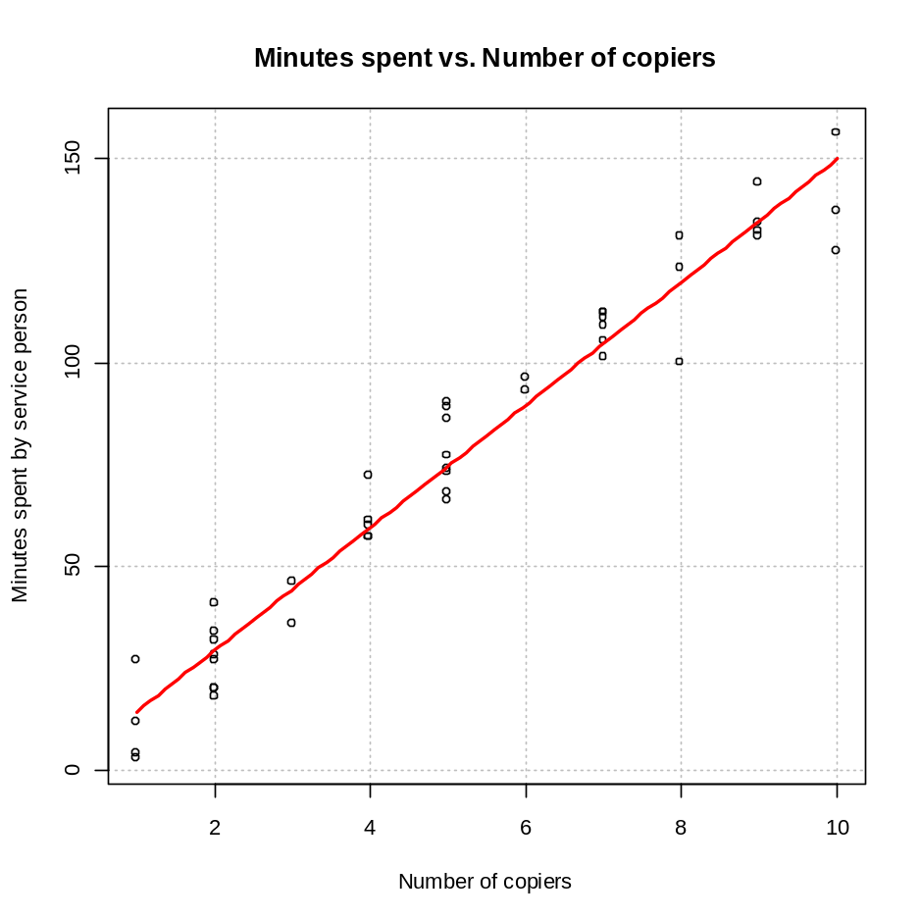

The model seems to capture the positive, linear relationship between minutes and copiers fairly well. The points do not deviate too much from the sample model.

c) b₀ represents the y-intercept of the model. In this case, it would be the estimated number of minutes of service needed when there are no copiers. Since the X variable (# of copiers) is at least one, we should not interpret this value.

d)

> #Do prediction at X = 5 - could have created a separate data.frame as well.
> predict(object = mod.fit, newdata = data.frame(copiers = 5))
[1] 74.59608

1.24
a)
> #Residuals put into a data set with the variables
> save.resid<-data.frame(copier, residuals = round(mod.fit$residuals,2))
> head(save.resid)
minutes copiers residuals
1 20 2 -9.49
2 60 4 0.44
3 46 3 1.47
4 41 2 11.51
5 12 1 -2.46
6 137 10 -12.77
> #Check sum to 0
> sum(mod.fit$residuals)
[1] -7.438494e-15

> #Sum of residuals^2
> sum(mod.fit$residuals^2)
[1] 3416.377
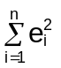 estimates Q. The value of 3416.38 is the smallest sum of squared errors possible.

b)
> #One way to obtain MSE
> summary.fit<-summary(mod.fit)
> summary.fit$sigma
[1] 8.913508
> summary.fit$sigma^2 #MSE
[1] 79.45063

MSE = 79.45 and 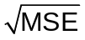 = 8.91

σ is in minute units.

  - Below is part of KNN’s answer key

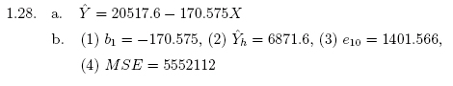

  - Below is part of KNN’s answer key and my answer

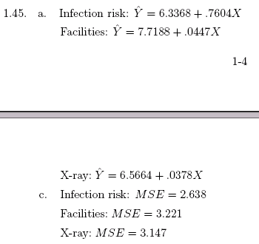

Here’s how I read in the data set on my computer.

> senic<-read.table(file = "C:\\chris\\UNL\\STAT870\\Instructor_CD\\Data
Sets\\Appendix C Data Sets\\APPENC01.txt", header = FALSE, col.names =
c("ID", "stay", "age", "infection", "culture", "xray", "beds", "school",
"region", "census", "nurses", "facilities"), sep = "")
> #Check first few and last few observations
> head(senic)
ID stay age infection culture xray beds school region census nurses facilities
1 1 7.13 55.7 4.1 9.0 39.6 279 2 4 207 241 60
2 2 8.82 58.2 1.6 3.8 51.7 80 2 2 51 52 40
3 3 8.34 56.9 2.7 8.1 74.0 107 2 3 82 54 20
4 4 8.95 53.7 5.6 18.9 122.8 147 2 4 53 148 40
5 5 11.20 56.5 5.7 34.5 88.9 180 2 1 134 151 40
6 6 9.76 50.9 5.1 21.9 97.0 150 2 2 147 106 40

> tail(senic)
ID stay age infection culture xray beds school region census nurses facilities
108 108 8.02 55.0 2.1 3.8 46.5 91 2 2 44 32 22.9
109 109 11.80 53.8 5.7 9.1 116.9 571 1 2 441 469 62.9
110 110 9.50 49.3 5.8 42.0 70.9 98 2 3 68 46 22.9
111 111 7.70 56.9 4.4 12.2 67.9 129 2 4 85 136 62.9
112 112 17.94 56.2 5.9 26.4 91.8 835 1 1 791 407 62.9
113 113 9.41 59.5 3.1 20.6 91.7 29 2 3 20 22 22.9

I fit the three different models (code and output excluded) and put the results into separate objects that began with “mod.fit.”. Below is my code for the plot. The par(mfrow = c(2,2)) part tells R to use the graphics “par”ameter function and make a 2×2 frame by rows in the graphics window. The plots are then successively put by rows into the window.

par(mfrow = c(2,2))
plot(x = senic$infection, y = senic$stay, xlab = "Infection", ylab = "Stay",
main = "Stay vs. Infection",
col = "black", pch = 1, panel.first = grid(col = "gray", lty = "dotted"))
curve(expr = mod.fit.infection$coefficients[1] +
mod.fit.infection$coefficients[2]*x, col = "red", lty = "solid", lwd =
2, add = TRUE, from = min(senic$infection), to = max(senic$infection))

plot(x = senic$facilities, y = senic$stay, xlab = "Facilities", ylab = "Stay",
main = "Stay vs. Facilities",
col = "black", pch = 1, panel.first = grid(col = "gray", lty = "dotted"))
curve(expr = mod.fit.facilities$coefficients[1] +
mod.fit.facilities$coefficients[2]*x, col = "red", lty = "solid", lwd
= 2, add = TRUE, from = min(senic$facilities), to = max(senic$facilities))

plot(x = senic$xray, y = senic$stay, xlab = "x-ray", ylab = "Stay",
main = "Stay vs. x-ray",
col = "black", pch = 1, panel.first = grid(col = "gray", lty = "dotted"))
curve(expr = mod.fit.xray$coefficients[1] + mod.fit.xray$coefficients[2]*x, col =
"red", lty = "solid", lwd = 2, add = TRUE, from = min(senic$xray), to =
max(senic$xray))
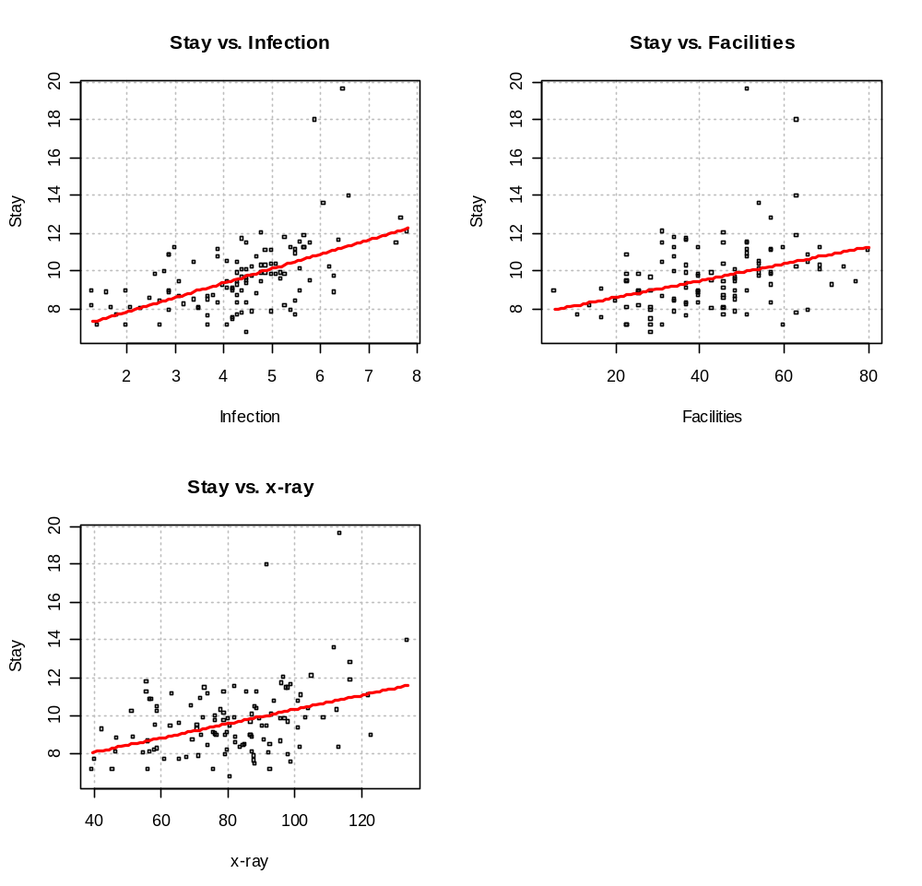

Page 23-24 proofs

1.
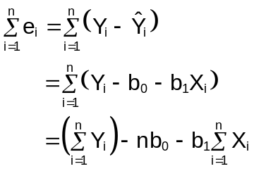
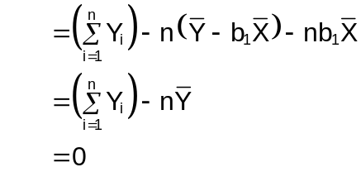

2. One can show the following partial derivatives: 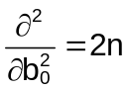, 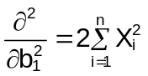, and 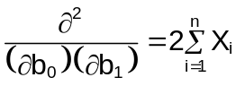
From calculus III, we need to show 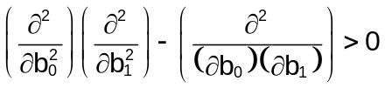 for the minimum of to be reached at the least squares estimators.

Now,
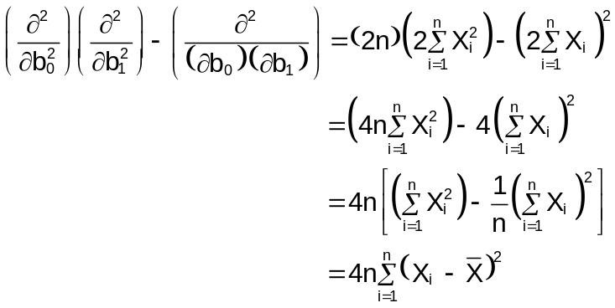
Notice that 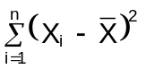 is always positive so .

3.

4.
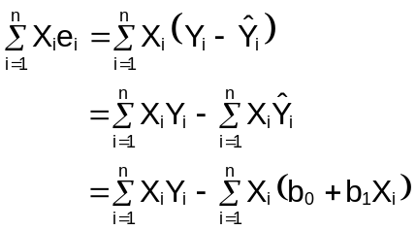
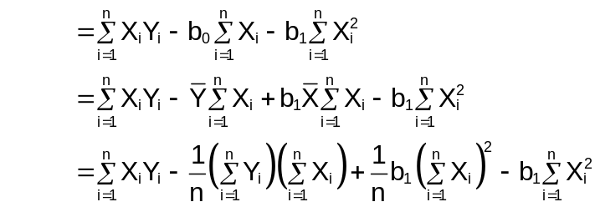
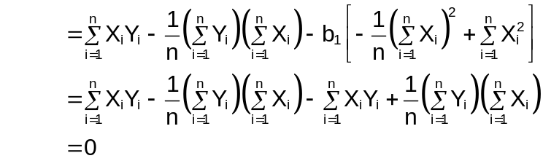

5.
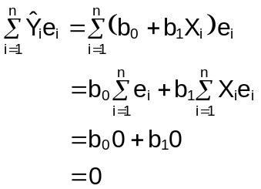

6.
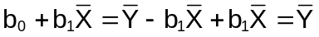

Thus, the regression line will go through 